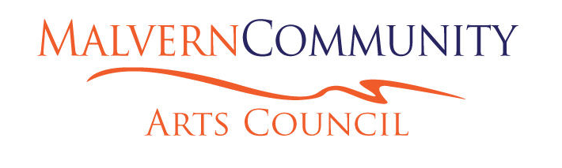

ANNUAL GENERAL MEETING
Wednesday, 29 March 2023, 7.30pm, Te Huanui, Darfield

AGENDA
Existing Membership
of Committees:

Executive Committee
Rob Lawrence
Lana Coles
Natalie Peters
Meg Morten
Alastair Nicol
Kirsty Peel
Paul Rosanowski
Judith Pascoe
Sean Ellis (MCB rep.)

Gallery Committee
Meg Morten (Chair)
Richard Hallowes
Lauren Carmichael
Lorraine Natusch
Performing Arts Committee
Melissa Jebson (Chair)
Janet MacDougall
Sherlee Sadler
Janet Taege
Diane Woodward
Artweek Committee
Meg Morten (Chair)
Emma Groom
Jane Couch
Mandy Cawford
Robin McIntosh
Alastair Nicol
Lana Coles
- Attendees:
Apologies:
- Adoption of the Minutes of the AGM, 6 April 2022
- Matters Arising from Minutes
- Chair’s Report 2022
- Financial Report
Sean Ellis to take the Chair for the Elections
- Election of Officers: Chairperson
Secretary
Treasurer
The elected Chair resumes chairing the meeting.
- Election of Executive Committee
- Election of Reviewer of Accounts
- General Business
- Adjournment
Note: A short executive meeting will be held
following the AGM.

