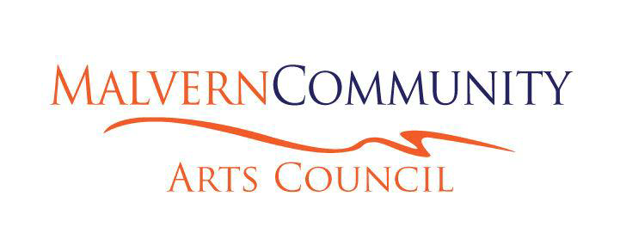

Minutes of the Annual General
Meeting of the Malvern
Community Arts Council
Held on Monday, 9 April 2019
in the Selwyn Gallery, Darfield at 7.00pm
1. PRESENT
Philip Baldwin (Chair), Alan Blackburn, Lana Coles (Secretary), Alan Harris, Melissa Jebson, Meg Morten, John Morten, Lorraine Natusch, Alastair Nicol (Treasurer), Judith Pascoe, Kirsty Peel, Paul Rosanowski, Sherlee Sadler, Sylvia Townshend, Carole van Leeuwen, Ruth Warren
2. APOLOGIES
Elizabeth Blackburn, Helen Collie, Bronwyn Hamilton, Nicola Hardy, Trevor and Liz Henderson, Dee Innes, Lorraine Jacobs, Maaike Kikstra, Janet Lilly, Rio Reilly, Janet Taege , Ruth Warren

Moved:
That apologies be received.
Philip Baldwin
Carried Carried

3. MINUTES
Moved:
That the minutes of the previous meeting held on 9 April 2018 be
confirmed as a true and accurate record.
Philip Baldwin
Carried
4. MATTERS ARISING FROM THE MINUTES
None

Chairperson's Report 2018 (attached)
Presented by Philip Baldwin.
Moved:
That the Chairperson's report be adopted.
Philip Baldwin Carried
Judith Pascoe congratulated Philip Baldwin and everyone else who contributed to MCAC.
5. FINANCIAL REPORT (attached)
The Treasurer (Alastair Nicol) presented the annual report from January 1st to December 31st 2018.
Moved:
That the financial report for the year ended 31st December, 2018 be adopted and approved.
Alastair Nicol / Bronwyn Hamilton Carried 6. Election of Officers
Judith Pascoe took the Chair for the Elections.
The following members were elected as office bearers.
Proposed Seconded
Chairperson Philip Baldwin Meg Morten Kirsty Peel
Secretary Lana Coles Meg Morten Kirsty Peel
Treasurer Alastair Nicol Philip Baldwin Melissa Jebson
Moved:
That the present committee is all elected.
(Nicola Hardy, Kirsty Peel, Meg Morten, Paul Rosanowksi)

Philip Baldwin
Carried

Moved :
That Ian Warren be retained as the Financial Examiner for MCAC for 2019.
Philip Baldwin
Carried

Judith Pascoe remains the Malvern Area Community Board representative on the Executive Committee.

7. General Business
Updating the Rules of the Malvern Community Arts Council Inc.
The changes included a simplification of language and updated to include the new Health and
Safety Law.
Moved:
That the adoption of the Rules as reviewed by the Exec. Committee and presented to the
AGM be accepted.
Meg Morten, Lorraine Natusch
Carried

The meeting adjourned at 8.45 pm.

Signed: Date:

(Chairperson)

