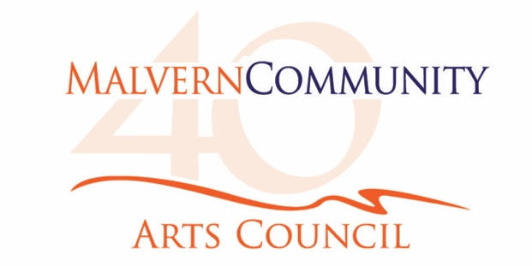

**Application for an Exhibition at the Selwyn Gallery**

**To the Gallery Committee, Malvern Community Arts Council**

I wish to apply to mount an exhibition in Gallery 1 in 2020. I understand that each exhibition is about one month long and confirm I have read and accepted the terms and conditions under which artwork is exhibited/displayed in the Selwyn Gallery. I am aware of the fee associated with an exhibition.

My medium is:

I would prefer:

I have attached:

* photographs illustrating the style of work I would exhibit
  + - * a résumé of previous exhibitions and other experience

My contact details are:

Name:

Address:

Postal code:

Email:

Phone: Mobile:

Signed: Date:

Please return this application form by email to [mcac.arts@gmail.com](mailto:mcac.arts@gmail.com) or by post to MCAC, PO Box 1, Darfield 7541.

Applications are considered at a Gallery Committee meeting each July for the following calendar year. You will be advised of the status of your application after this meeting. Thank you for considering exhibiting in the Selwyn Gallery.

If you have any questions regarding this application, contact [mcac.arts@gmail.com](mailto:mcac.arts@gmail.com)

**Conditions of Exhibiting/Displaying Artwork**

**in the Selwyn Gallery**

1 Artworks must normally be recent original work of the artist. Prints and photographs must be numbered from a limited edition.

2 All artworks must be for sale and priced including Gallery commission and GST (if applicable) unless previously agreed with the Gallery Committee.

3 Display – All paintings, etc must be professionally framed ready to hang, complete with cord.

4 Labelling – All items must have a title, medium, name of exhibitor and selling price printed on the back of the item. Any specific instructions should be attached to the exhibit.

5 Freight – Works not being collected from the gallery must have return freight prepaid. MCAC will not cover the cost of freight. All works consigned to the gallery must be securely packaged; the same packaging will be used for the return of artworks.

6 Liability/Insurance – Insurance of work to and from the gallery is the sole responsibility of the exhibitor. MCAC carries insurance against theft or fire damage to your work while on exhibition.

7 The Malvern Community Arts Council reserves the right to choose the artworks to be exhibited/displayed.

8 Please ensure that work matches that listed on your submission form.

9 As the Selwyn Gallery has little storage space, artworks must be collected on the date specified or a storage fee may be charged.

1. A commission of 25% (plus GST – a total of 28.75%) of the stated selling price will be deducted on all sales. The proceeds of sold works (less commission and its GST) will be paid to your nominated bank account or by cheque by the 20th of the month following receipt of payment for the work.
2. All Exhibitors are required to be current Artist Members of MCAC. This provides the opportunity for selected work to be displayed for sale in Gallery 2.
3. Artist Members also receive MCAC newsletters and invitations to Selwyn Gallery previews and special occasions, as well as discounted ticket prices to some major events.

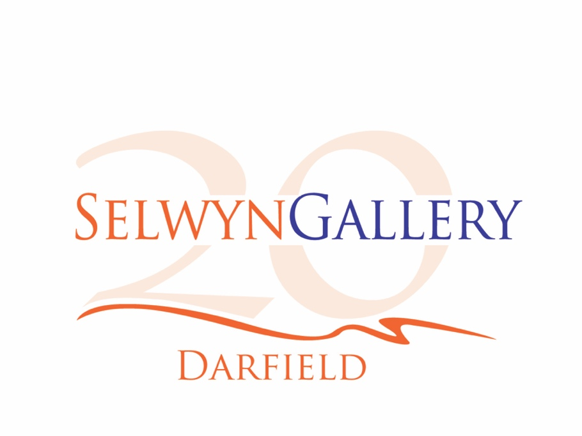

**Schedule of Fees for Exhibiting in the Selwyn Gallery**



As an example, for an exhibition with 3 artists, each artist pays $146.25 towards the costs of mounting the exhibition and for an Artist Membership of MCAC.

Exhibitors who are current Artist Members of MCAC, only pay the exhibition costs.

An invoice for the appropriate fees will be issued by the MCAC Treasurer close to the opening date of each Exhibition.